Ydka; mS;r úÿy, - fld<U 04

புனித பேதுரு கல்லூரி, கொழும்பு 4

***St. Peter's College - Colombo 04***

ish¿u ysñlï weúßKs $ All Rights Reserved

St. Peter's College

St. Peter's College

St. Peter's College

புனித பேதுரு கல்லூரி

புனித பேதுரு கல்லூரி

புனித பேதுரு கல்லூரி

புனித பேதுரு கல்லூரி

புனித பேதுரு கல்லூரி

புனித பேதுரு கல்லூரி

புனித பேதுரு கல்லூரி

புனித பேதுரு கல்லூரி

Ydka; mS;r úÿy,

Ydka; mS;r úÿy,

Ydka; mS;r úÿy,

Ydka; mS;r úÿy,

Ydka; mS;r úÿy,

Ydka; mS;r úÿy,

Ydka; mS;r úÿy,

Ydka; mS;r úÿy,

Ydka; mS;r úÿy,

Ydka; mS;r úÿy,

St. Peter's College

St. Peter's College

St. Peter's College

St. Peter's College

St. Peter's College

St. Peter's College

St. Peter's College

St. Peter's College

St. Peter's College

St. Peter's College

புனித பேதுரு கல்லூரி

புனித பேதுரு கல்லூரி

புனித பேதுரு கல்லூரி

புனித பேதுரு கல்லூரி

புனித பேதுரு கல்லூரி

புனித பேதுரு கல்லூரி

புனித பேதுரு கல்லூரி

புனித பேதுரு கல்லூரி

Ydka; mS;r úÿy,

Ydka; mS;r úÿy,

Ydka; mS;r úÿy,

Ydka; mS;r úÿy,

Ydka; mS;r úÿy,

Ydka; mS;r úÿy,

Ydka; mS;r úÿy,

Ydka; mS;r úÿy,

Ydka; mS;r úÿy,

Ydka; mS;r úÿy,

St. Peter's College

St. Peter's College

St. Peter's College

St. Peter's College

St. Peter's College

St. Peter's College

St. Peter's College

34

E

I

**úoHdj**

**Science**

**meh folhs**

**Two hours**

**10 fY%aKsh – úfYaI we.hsu ^m<uq jdrh& - 2022**

**தரம் 10 - முதலாந் தவணைப் பரீட்சை (Kjyhk; jtiz) - 2022**

***Grade 10 – Special Evaluation (First Term) - 2022***



**Part - I**

01. What is the type of polysaccharide stored in plant leaves,

1. Cellulose 2. Glycogen 3. Starch 4. Sucrose

02. Identifying by using the Benedict solution,

1. Starch 2. Glucose 3. Glycogen 4. Cellulose

03. The false statement regarding proteins,

1. Consisting C, H, O and N 2. It’s a biological molecule

3. Act as hormones 4. Its important for storing water

04. What is the reason for chlorosis near the veins of leaves,

1. Lack of N 2. Lack of S 3. Lack of Fe 4. Lack of P

05. The diagram illustrate the structure of Nucleotide,

**A**

**B**

**C**

Name the A, B, C accordingly,

1. Nitrogenous base, Pentose Sugar group, Phosphate group

2. Phosphate group, Pentose Sugar group, Nitrogenous base

3. Pentose Sugar group, Nitrogenous base, Phosphate group

4. Phosphate group, Nitrogenous base, Pentose Sugar group

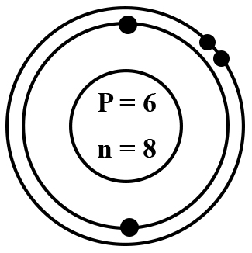

06. The electronic configuration of an atom,

What is the true statement about the atom,

1. Atomic number is 8

2. Atomic mass number is 13

3. Electronic configuration is stable

4. Atomic number is 6

* **Answer (7), (8), (9) and (10) questions by using the below mentioned periodic table.**

**A**

**G**

**B**

**C**

**D**

**E**

**F**

**H**

07. Select the Bi-valent nonmetal,

1. B 2. C 3. D 4. E

08. Select the element is having highest electron negativity,

1. A 2. E 3. F 4. G

09. Select the element is having least first ionization energy,

1. A 2. E 3. F 4. G

10. The formulae of a compound is forming between E and G,

1. EG3 2. E2 G 3. G2 E 4. GE

11. The correct formulae of sodium carbonate,

1. Na2 Co3 2. Na (Co3)2 3. Na Co3 4. Na2 (Co3)2

12. Which element is using to produce milk of magnesia,

1. Na 2. S 3. Ca 4. Mg

13. Which gas used to fill-up thermometers,

1. O2 2. Cl2 3. N2 4. F2

14. What is the word using for rate of changing velocity,

1. Velocity 2. Speed 3. Displacement 4. Acceleration

15. Select answer is having only vector quantities,

1. Distance $γ$ Displacement 2. Speed $γ$ velocity

3. Displacement $γ$ Velocity 4. Acceleration speed

16. This is a displacement – time graph for a moving object,

**Displacement**

**(m)**

30

0

10

**Time (s)**

Select the false statement,

1. The object is moving with an uniform velocity.

2. The force exerts on the object is zero.

3. The velocity of the object increases with time.

4. The object is having a linear motion.

17. The correct measuring unit for Accelerations,

1. ms-1 2. ms-2 3. ms 4. Nm

18. An object is moving 600 m within 2 minutes what is the speed of the object,

1. 300 ms-1 2. 100 ms-1 3. 50 ms-1 4. 5 ms-1

1000 kg

500 N

19. What is the acceleration of the car,

1. 2.

3. 4.

20. Due to deficiency of vitamin A,

1. Teeth decoying 2. Cetadation of houes

3. Effect for blood clotting 4. Night blindness

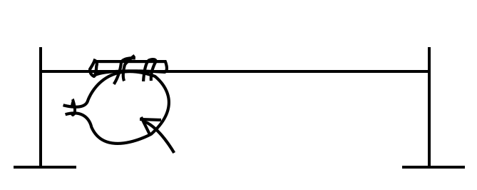

Balloon

21.

Which is illustrate by the above diagram,

1. Newton’s 1st law 2. Newton’s 2nd law

3. Newton’s 3rd law 4. Momentum

22. What is the velocity of a vehicle is moving 200 m in 10 S,

1. 2 ms-1 2. 200 ms-1 3. 20 ms-1 4. 0.2 ms-1

23. Select the correct answer regarding isotopes,

1. Having different atomic numbers. 2. Having the same atomic mass number.

3. Having the same atomic of neutrons. 4. Having the same atomic protons.

24. Who was the scientist discoved cell,

1. Glyten 2. Shewann 3. Radolf 4. Robert Hook

25. What is the organelle can be observed through light microscope,

1. Nucleous 2. Golgi complex 3. Mitochondria 4. Above all

26. What is the below mentioned organelle and its function,

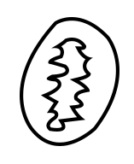

1. Golgi complex - Secretion

2. Ribosome - Secretion of proteins

3. Chloroplast - Serration of stevoids

4. Mitochondria - Respiration

27. Cell wall of plant cell is build up by,

1. Proteins 2. Lipids 3. Cellulose 4. Lactose

28. The non-living thing in a cell,

1. Cell wall 2. Cell membrane 3. Golgi Complex 4. Nucleous

29. The energy get produce in a cell by,

1. Necleous 2. Chloro plast 3. Mitochondria 4. Golgi Complex

30. Not a special characteristic of water,

1. Act as a coolant 2. Having high specific heat capacity.

3. It’s a good solvent 4. Having low boiling point

31. The object is situated on the ground projected vertically upwards by velocity of 40ms-1. What its velocity in 6 seconds?

1. 0 2. 5 ms-1 3. 10ms-1 4. 20ms-1

32. What is the purpose doing bi-urette test,

1. Identifying proteins 2. Identifying Lipids

3. Identifying starch 4. Identifying monosaccharide

33. The object is projected vertically upwards of the velocity of 60 ms-1. What is the time duration when its reaches the maximum height,

1. 60 S 2. 30 S 3. 10 S 4. 6 S

34. Its not a form of Carbon,

1. Graphite 2. Diamond 3. Coal 4. Dry ice

35. In which element the electronic negativity won’t be considered,

1. Na 2. C 3. O 4. Ne

36. Which element gives luminous white flame by heating?

1. Na 2. Mg 3. Ca 4. Al

37. A - Electron negativity get increases from left to right in a period.

B - The first group of elements are having the highest first ionization energy.

C - Electron negativity get decreases from top to the bottom of a group.

What are the true statements,

1. A & B 2. B & C 3. A & C 4. A, B & C

38. The monosaccharide won’t have sweet taste,

1. Glucose 2. Fructose 3. Galactose 4. Maltose

39. Number of H atoms are present in a (NH4)2 SO4,

1. 2 2. 4 3. 8 4. 12

40. Which element is having the density less than water,

1. Na 2. Ca 3. Mg 4. Al